# BAW Content Sample Application

This document describes how to install and configure the Content Sample Application built with the Content Services Toolkit for a Business Automation Workflow (BAW) environment. By default, the application provides a search that queries for documents in a FileNet Content Manager repository.

## Import the application

Go to the Process apps view in BAW, click the Import button, browse to the Content_Sample_Application.twx file you downloaded from the GitHub repository, then click OK:

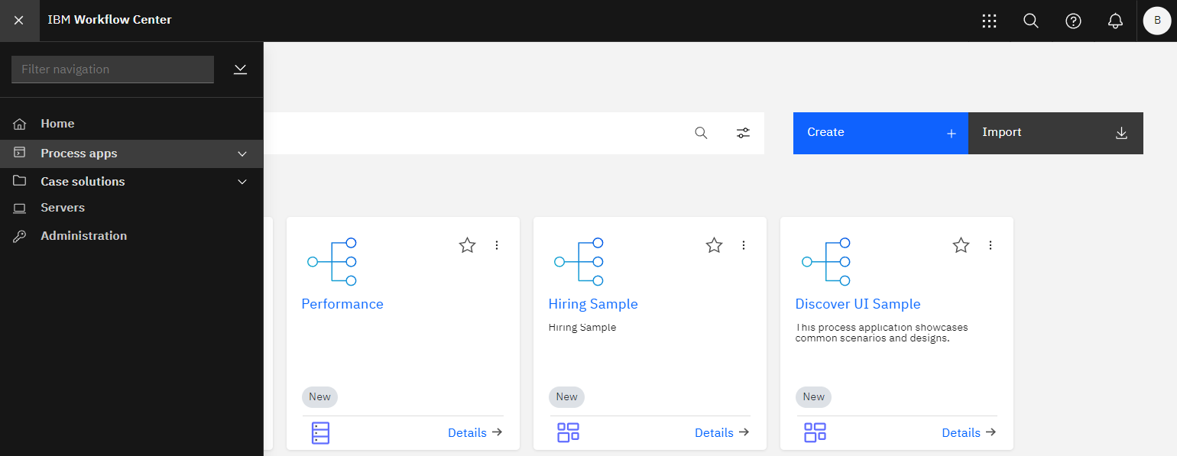

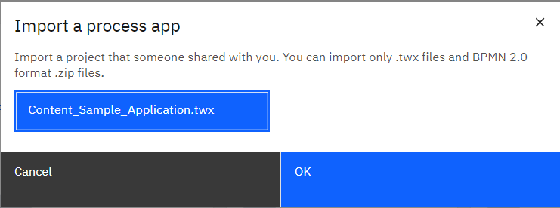

The application appears in the Process apps list: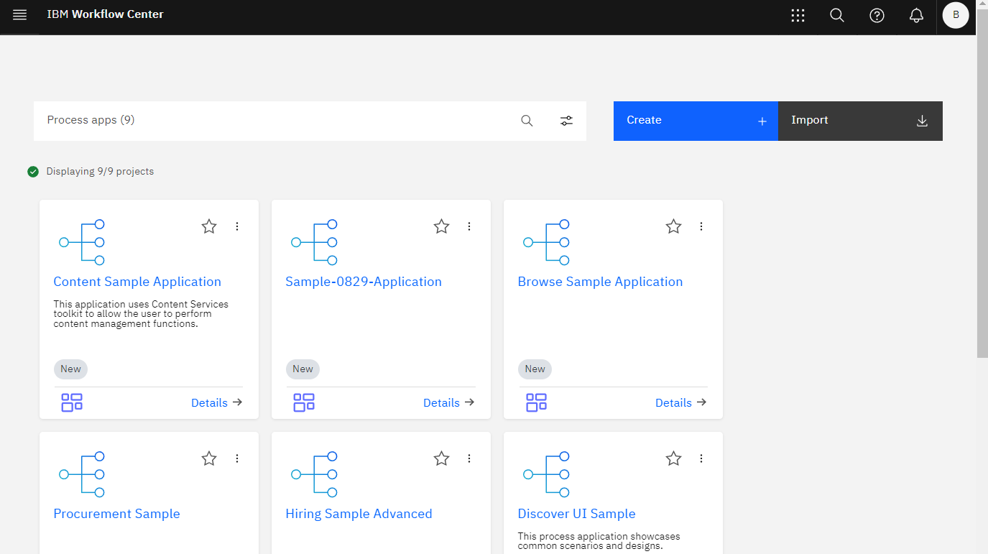

## Configuring the application in BAW application designer

There are five views (or components) in the application: Content List, Document Thumbnail, Content Properties, File Drop Zone and Search.

The application’s Start Page uses the Grid with 2 columns to place the components onto the page. The main container has the horizontal span value of 12. The left grid layout cell has the horizontal span value of 9 and the right grid layout cell has the horizontal span value of 3.

You must configure each view with the name of the repository (object store) and the graphql service URL.

Setting up the Environment variables

First we need to define the graphqlService and objectStoreName values in the Environment Variables section in the Process App Settings.

The environment variables can define separate values for Default, Development, Test, Staging or Production environments.

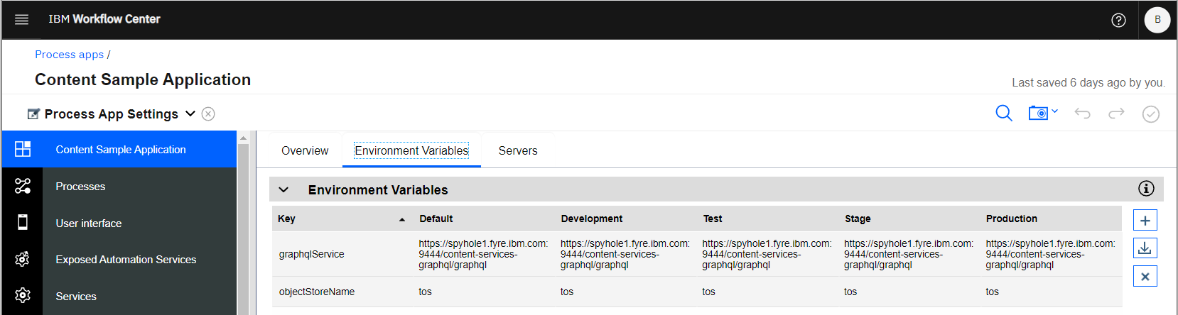

The application came with a Human-side Client Service, named “Content Sample Application” that already has some private variables and some environment variables defined as follows:

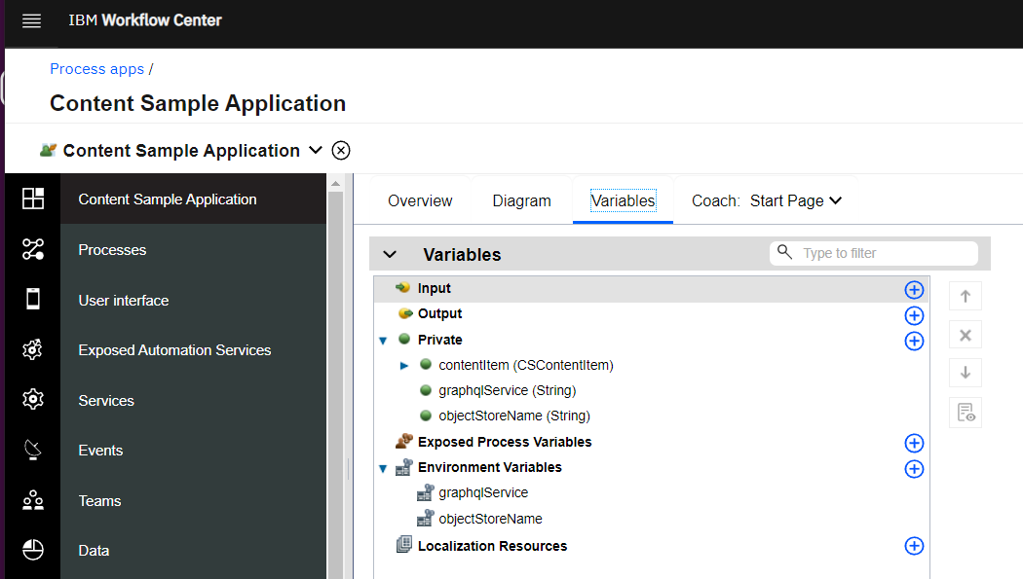

Note that to bind the graphqlService and objectStoreName local variables with the environment variables, we do that here in the Pre-Execution script of the Start Page:

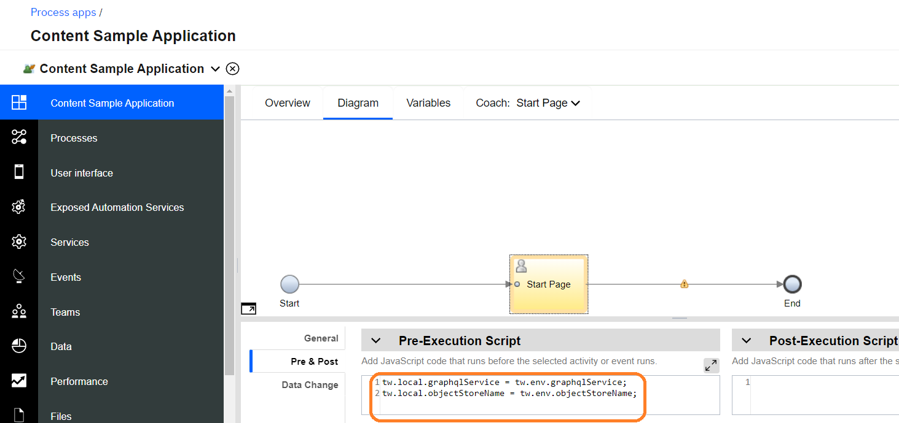

This application also was set with the option “Startable Service (Launched from Process Portal)” so that it can be launched from a Process Portal:

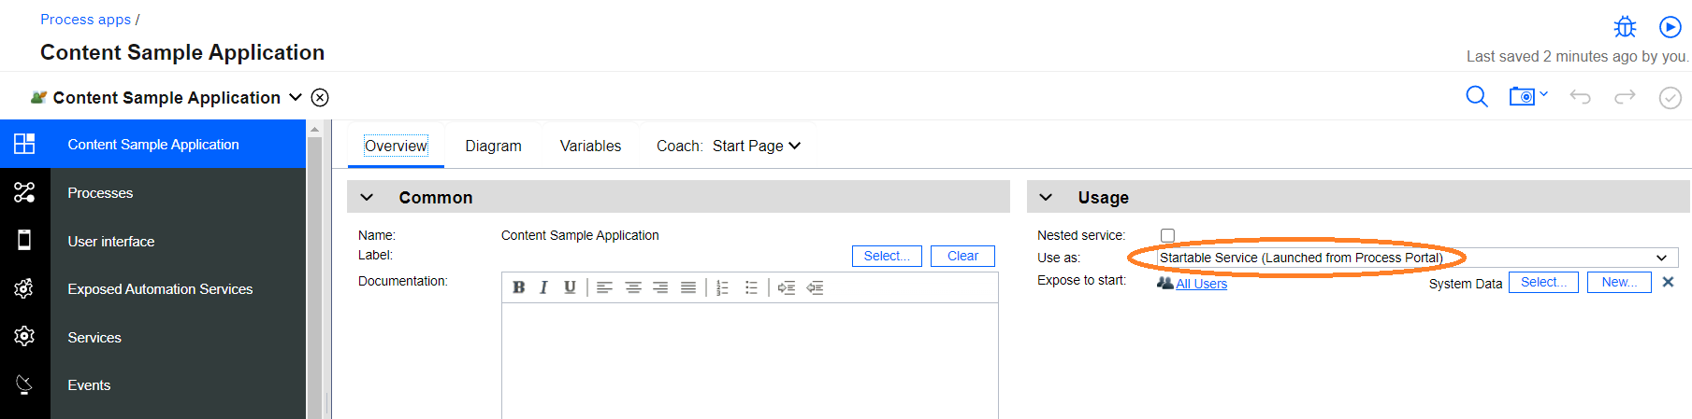

Configure the Content List component to be loaded with Search:

* From the Content Sample Application -> Start Page, first click on the Content List component, then the Properties will appear in the bottom of the screen. Go to General and check for the binding of the contentItem, as shown in the screen shot below:

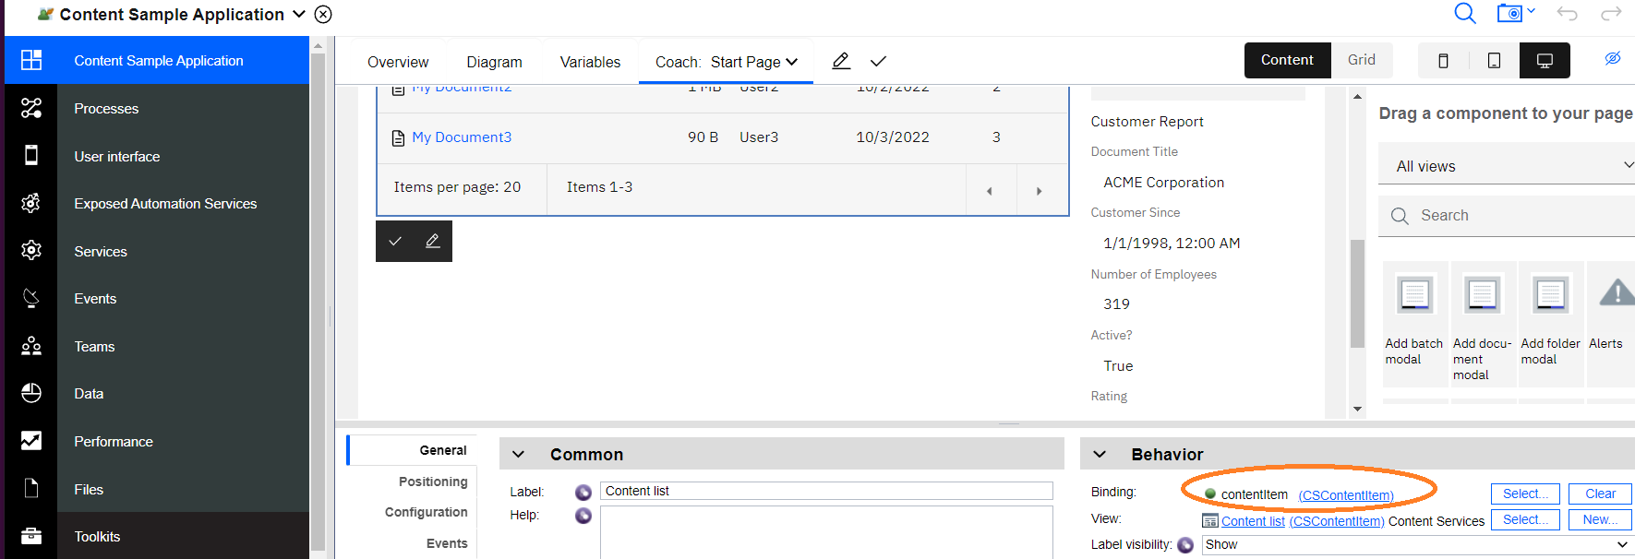

* Make sure that in the Configuration/Services tab, the repository name and the graphql service are linked and referenced:

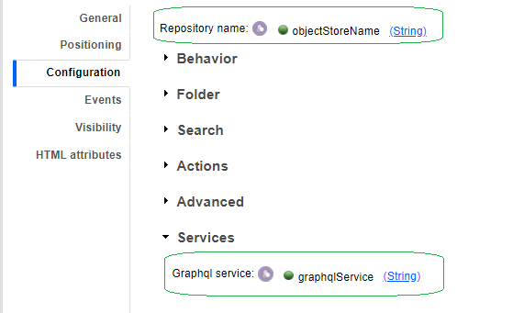

* By default, the Configuration has the “Enable search filter” set to false. The search section will be used instead. The query will search for documents with the operator of “like”. When the application comes up, a user can enter a string to perform a search. There will not be any folder to browse.

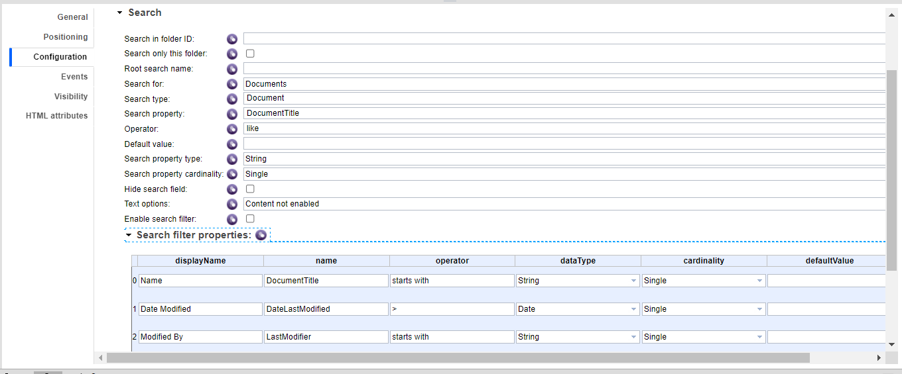

* When the “Enable search filter” is enabled, the “Search filter properties” section will be used.
* You can also configure the application to start browsing at a different folder by supplying a value for the Folder ID. For example, to browse the repository starting at the Root folder, specify “//” for the Folder ID:

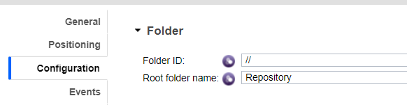

* In this content list, we also added a context menu action to view a list of versions for a selected document in the “*On context menu open*” event.
* Also note that in this content list, the “View mode” is set to “Details”. You can change to “Magazine” view or one of the other options, to toggle between these modes at run time.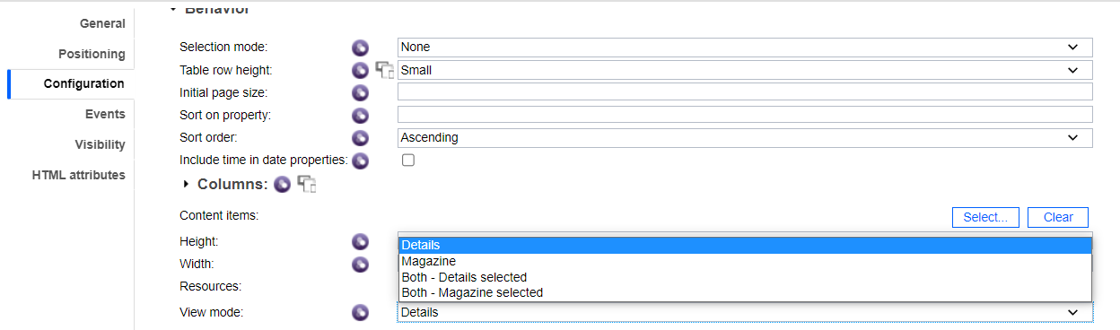

Configure the File Drop Zone component to add a document to the repository:

* Make sure that in the Configuration/Services tab, the repository name and the graphql service are linked and referenced.

Configure Document Thumbnail component to display the document thumbnail image:

* Make sure that in the Configuration/Services tab, the repository name and the graphql service are linked and referenced.

Configure the Document Reference component to display document objects:

* Make sure that in the Configuration/Services tab, the repository name and the graphql service are linked and referenced.
* By default, this component is set to support adding documents to a repository. The “Add document mode” was set to “Add with properties”. If you like to add the documents without any UI, you can select the option “Add no UI”.
* Also, the “Enable actions” was checked to enable the context menu for content management actions.

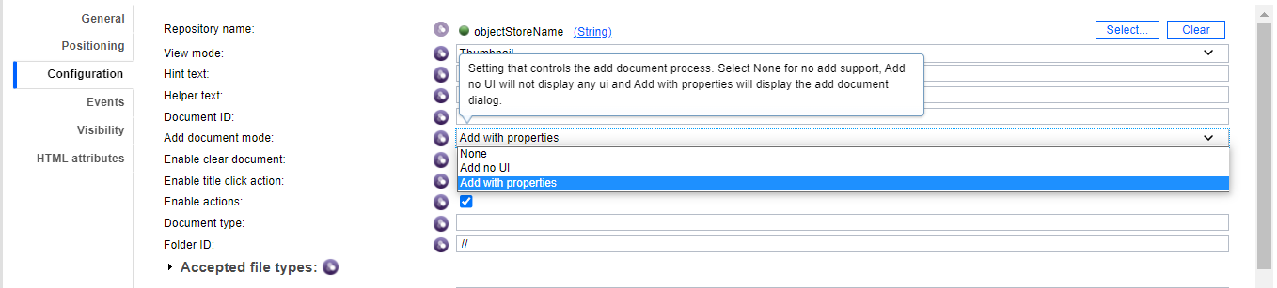

Configure the Content Properties component to display and edit document properties:

* Make sure that in the Configuration/Services tab, the repository name and the graphql service are linked and referenced.
* By default, this component has the “Display buttons for editing property values” option checked to enable editing of properties.

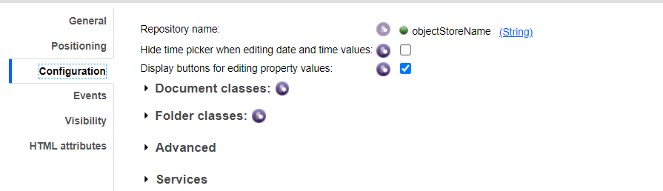

Configure the Search to execute a search query:

* Make sure that in the Configuration/Services tab, the repository name and the graphql service are linked and referenced.
* This application has the Search’s Configuration defined as follows:

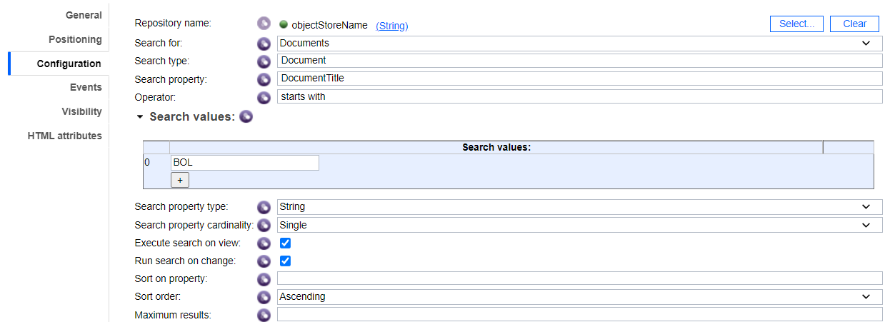

The Search component Visibility is set to “None”.

The application has a button to allow a user to click to execute the Search (searching for all documents that have a Document Title that starts with “BOL”) and send the results count to an Alert modal.

## Save and run your application

Once all views are configured, click the check icon in the upper right part of the page to save your changes:

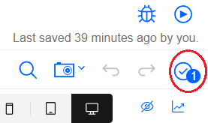

Then, click the Run link in the upper right of the page to run the application:

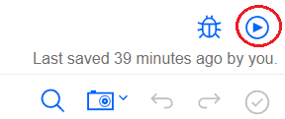

## Using the Content Sample Application

This is how the application looks when it first comes up:

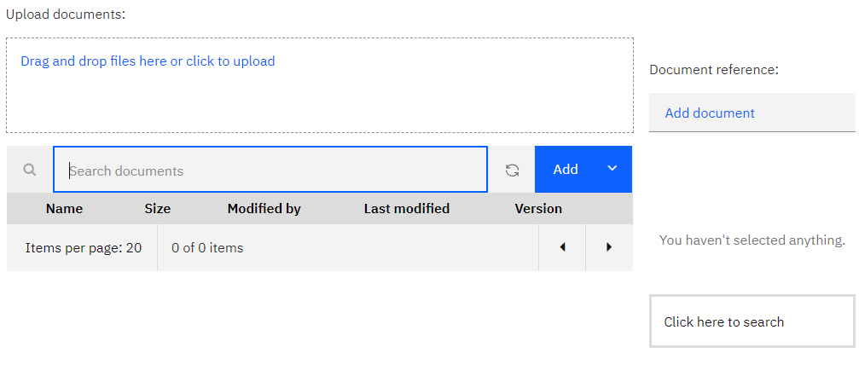

* The application provides a search filter (above the Content List) to let the user retrieve a list of documents to work with. For example, enter “BOL” in the filter and see that the Content List is loaded with the new search results:

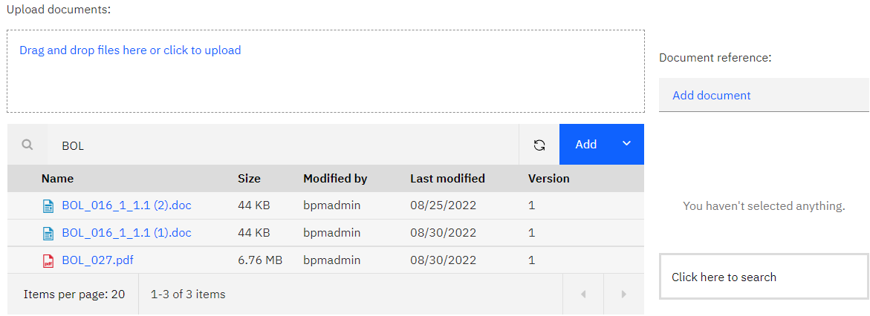

* To add new documents, click the “*Drag and drop files here or click to upload*” link above the Content List or click on the “*Add document*” link from the Document Reference.
* To display a context menu for an individual item, click on the button in the far right of a document row:

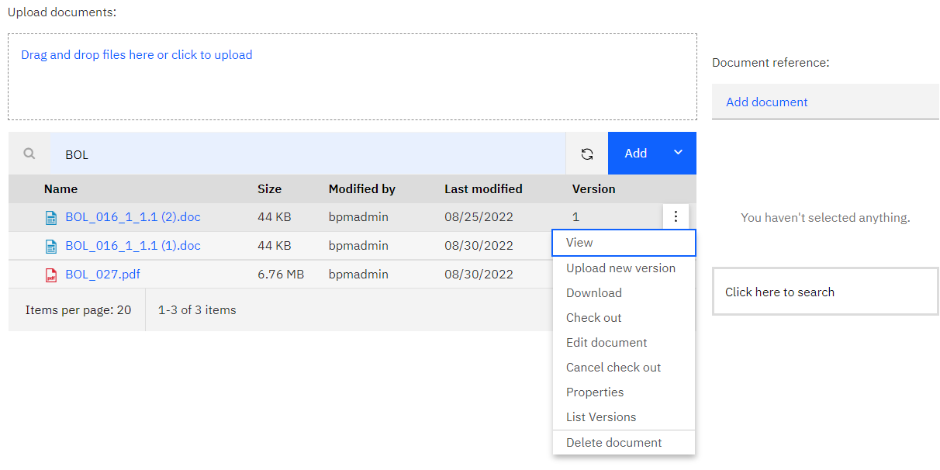

Note that clicking on View menu action would yield an alert unless the Viewer has been integrated into the system:

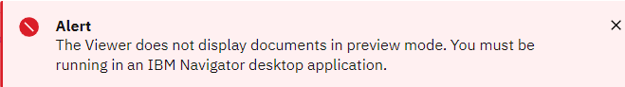

* Clicking on the name of an item displays its properties in the Content Properties view on the right side of the window. Clicking the name of a document also displays the thumbnail of the document in the Document Thumbnail view and the document object in the Document Reference view. Properties may be edited and saved by clicking the buttons at the top of the properties view.

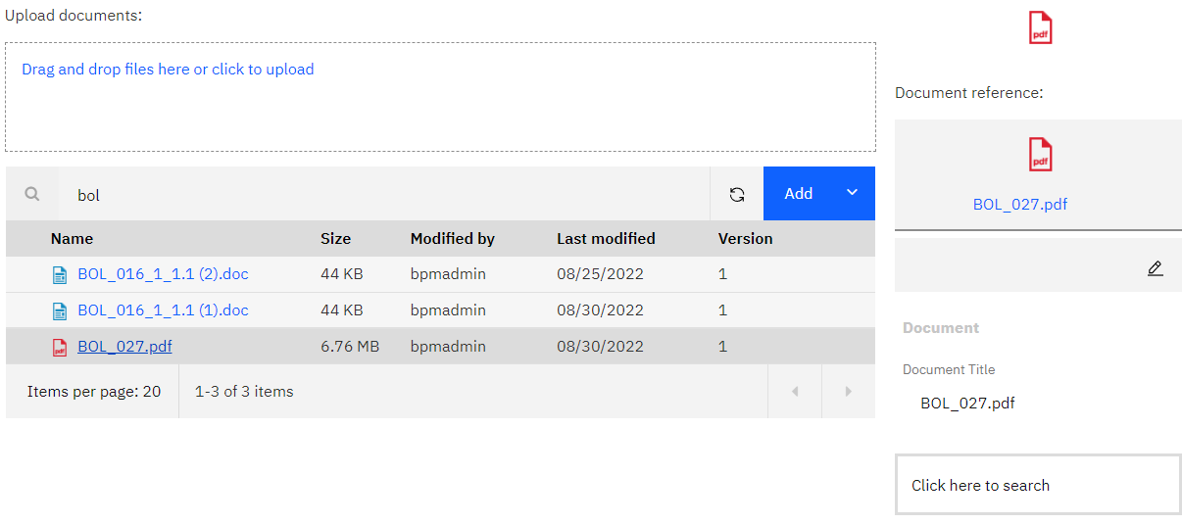

* Clicking on the button “*Click here to search*” to get the number of documents that have document titles starting with “BOL”.

